1.Create a virtual machine mention the procedure steps for creating virtual machine.

**Procedural steps:**

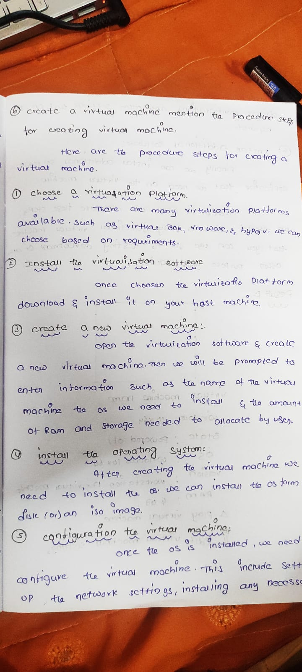

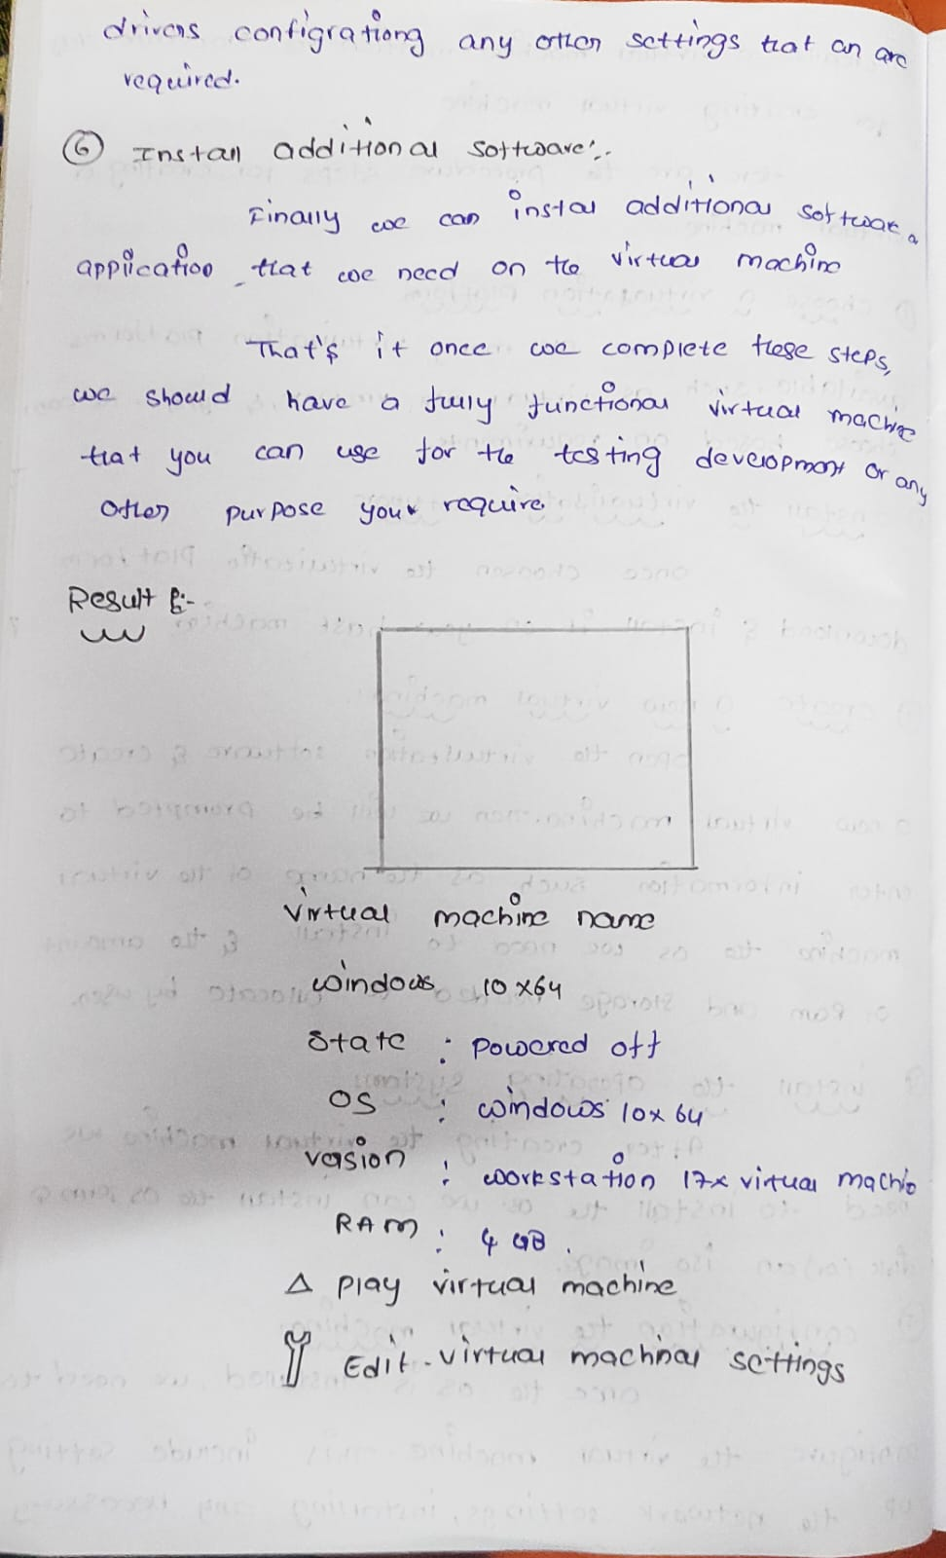

**RESULT:**

